🐢
Turtle Microarchitecture and Detailed Design Specification
Tom Riley
2026-01-06
Version 0.2.1

Table of Contents
Overview 3
Modules 4
Clock and Reset Generator 4
Arithmetic Logic Unit (ALU) 4
Instruction Decoder 5
Program Counter 6
Register File 7
Instruction Memory 8
Data Memory 8
Interconnection (Headers) 9
Index of Tables
Table 1: Clock and Reset Generator Module Ports 5
Table 2: Arithmetic Logic Unit (ALU) Module Ports 5
Table 3: Instruction Decoder Module Ports 6
Table 4: Program Counter Module Ports 7
Table 5: Register File Module Ports 8
Table 6: Instruction Memory Module Ports 9
Table 7: Data Memory Module Ports 9
Table of Figures
Figure 1 Turtle CPU Overview Block Diagram 3
Figure 2 Turtle CPU Detailed Top Level Diagram 3
Figure 3 Interconnection Between Different Modules 9
References
- Turtle CPU Architecture

Overview
The Turtle CPU is an 8-bit Microcomputer CPU designed to be made from discrete 74-series TTL logic chips. The name “Turtle” comes for “TTL” and from the design philosophy of being reliable—and slow. The design is an implementation of the Turtle CPU Architecture Error: Reference source not found. The following figures show a high-level overview of the blocks in the design, as well as the detailed module connections.

Figure 1 Turtle CPU Overview Block Diagram

Figure 2 Turtle CPU Detailed Top Level Diagram

Modules

Clock and Reset Generator
Table 1: Clock and Reset Generator Module Ports
Port Name | Direction | Width | Description
reset_btn | Input | 1 | Reset button input (active high), simulating an external reset button
manual_clk_sw | Input | 1 | Manual clock switch to select between automatic and manual clock
pulse_clk_btn | Input | 1 | Manual clock pulse button, simulating an external clock step button
clk | Output | 1 | System clock output, free running based on parameter value
reset_n | Output | 1 | Active-low reset signal

Arithmetic Logic Unit (ALU)
Table 2: Arithmetic Logic Unit (ALU) Module Ports
Port Name | Direction | Width | Description
operand_a | Input | DATA_W | First operand input
operand_b | Input | DATA_W | Second operand input
alu_func | Input | 3 | ALU function selector (ADD, SUB, AND, OR, XOR, INV) (Encoding defined in )
output_enable | Input | 1 | Enable signal for ALU result output tri-state. When low, alu_result is Hi-Z to allow the bus to be driven elsewhere
alu_result | Output | DATA_W | Tri-state ALU result output
zero_flag | Output | 1 | Zero flag (result == 0)
positive_flag | Output | 1 | Positive flag (MSB of result == 0)
carry_flag | Output | 1 | Carry flag (for ADD/SUB operations)
signed_overflow | Output | 1 | Signed overflow flag (for ADD/SUB operations)

Instruction Decoder
Table 3: Instruction Decoder Module Ports
Port Name | Direction | Width | Description
instruction | Input | INST_W | 16-bit instruction word
address_immediate | Output | I_ADDR_W | Immediate address for branch/jump instructions
acc_immediate | Output | DATA_W | Tri-state immediate value for accumulator
alu_operand_b_immediate | Output | DATA_W | Tri-state immediate value for ALU operand B
acc_write_enable | Output | 1 | Enable signal for accumulator write
write_put_acc | Output | 1 | Enable signal for PUT operation (ACC → register)
read_get_acc | Output | 1 | Enable signal for GET operation (register → ACC)
reg_addr | Output | 4 | Register address for register file access
read_data_output_enable | Output | 1 | Tri-state enable signal for register read data output
status_write_enable | Output | 1 | Enable signal for status register write
data_memory_write_enable | Output | 1 | Enable signal for data memory write
data_memory_output_enable | Output | 1 | Tri-state enable signal for data memory read
jump_branch_select | Output | 1 | Enable signal for jump/branch operations
immediate_address_select | Output | 1 | Select immediate address for branch
unconditional_branch | Output | 1 | Flag for unconditional branch
pc_relative | Output | 1 | Whether to jump relative to PC (1) or to an absolute address (0)
branch_condition | Output | 3 | Branch condition selector
alu_output_enable | Output | 1 | Enable signal for ALU output
alu_function | Output | 3 | ALU function selector (Encoding defined in [1])

Program Counter
Table 4: Program Counter Module Ports
Port Name | Direction | Width | Description
clk | Input | 1 | System clock
rst_n | Input | 1 | Active-low reset signal
imar | Input | I_ADDR_W | Instruction Memory Address Register
address_immediate | Input | I_ADDR_W | Immediate address for branch instructions
jump_branch_select | Input | 1 | Enable signal for jump/branch instructions
immediate_select | Input | 1 | Select immediate address for branch
pc_relative | Input | 1 | Whether to jump relative to PC (1) or to an absolute address (0)
unconditional_branch | Input | 1 | Flag for unconditional branches
status_register | Input | DATA_W | Status register containing flags
branch_condition | Input | 3 | Branch condition to evaluate
pc | Output | I_ADDR_W | Program Counter output

Register File
Table 5: Register File Module Ports
Port Name | Direction | Width | Description
clk | Input | 1 | System clock
reset_n | Input | 1 | Active-low reset signal
acc_out | Output | DATA_W | Accumulator output (always available)
acc_in | Input | DATA_W | Accumulator input from tristate bus
acc_write_enable | Input | 1 | Write enable for accumulator
read_get_to_acc | Input | 1 | Enable for internal tristate from read_data to acc_in
write_put_acc | Input | 1 | Enable for internal write from ACC to reg[reg_addr]
reg_addr | Input | 4 | Register address for read/write operations
read_data_output_enable | Input | 1 | Enable for read data tristate output
read_data | Output | DATA_W | Tri-state output for read data
status_write_enable | Input | 1 | Enable for status register write
zero_flag | Input | 1 | Zero flag from ALU
negative_flag | Input | 1 | Negative flag from ALU
carry_flag | Input | 1 | Carry flag from ALU
overflow_flag | Input | 1 | Overflow flag from ALU
dmar | Output | D_ADDR_W | Data Memory Address Register
imar | Output | I_ADDR_W | Instruction Memory Address Register

Instruction Memory
Table 6: Instruction Memory Module Ports
Port Name | Direction | Width | Description
addr | Input | I_ADDR_W | Address input for instruction fetch
instruction | Output | INST_W | 16-bit instruction output

Data Memory
Table 7: Data Memory Module Ports
Port Name | Direction | Width | Description
data_addr | Input | D_ADDR_W | Address input for data memory access
write_data | Input | DATA_W | Data input for memory write operations
write_enable | Input | 1 | Enable signal for memory write
output_enable | Input | 1 | Enable signal for memory read output
read_data | Output | DATA_W | Tri-state data output for memory rea

Interconnection (Headers)
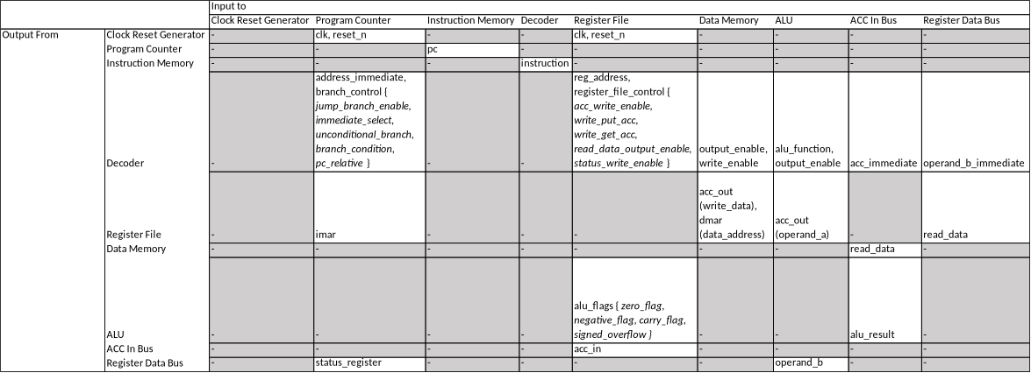
Figure 3 Interconnection Between Different Modules

